REV 2/2016
MINNESOTA YMCA MODEL UNITED NATIONS
STATUS REPORT

The Status Report is designed to guide the country group’s research so all members may fully represent the country at the conference. This document covers a good deal of information but there may be other important info not included – do not limit research to ONLY these items.
- Answer the questions as completely as possible – may be used during the conference
- Type or neatly write your answers
- Keep a copy for each member of the country group

GENERAL INFORMATION
Point out the country's location on the map (circle, color in or otherwise indicate the country)

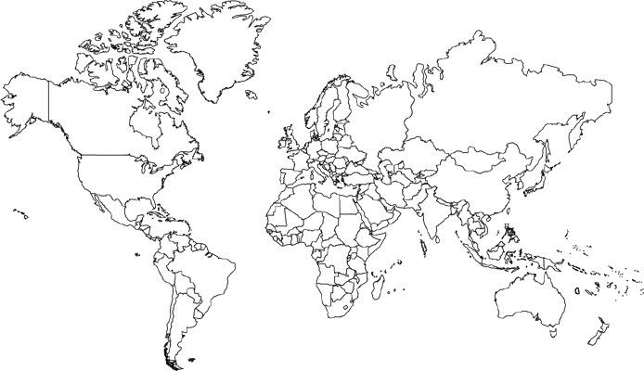

Country Name _________________________________________ Capitol City _______________________________

Continent _______________________________________________ Population ________________________________

Country Rank (surface area) _________________________ Country Rank (population) ____________

Official Language(s) _____________________________________________________________________________________________

Other Languages Spoken ______________________________________________________________________________________

Year Country Joined the UN ____________________________ Government Type _______________________

HISTORY

Date country came into existence (or date of most recent constitutional government) _________

What groups of people make up the country? Include both indigenous people and any waves of immigration.

Has the country ever been colonized? When and by whom?

Has the country colonized or gained control over others? When and who?

Are there any major wars in the country's PAST – either foreign or civil? When and why did they happen and what was their outcome?

Are there any CURRENT conflicts with other countries, groups or organizations – or any CURRENT internal conflicts? Briefly describe them.

ECONOMY & TRADE

What is the economic status of the country?

- Development level
- Per-capita income
- Gross Domestic Product (GDP)
- Economic status in comparison with neighboring countries

What are the primary industries of the country?

- Crops, livestock, other farm products
- Manufacturing
- Education, technology, business
- Travel, tourism

What is the status of the labor force?

- Employment/unemployment levels
- Labor organization (unions, guilds)

What are the natural resources?

- Crops, minerals, wildlife
- Attributes (water, land, timber, etc.)

What is the situation with world trade?

- Import/export products
- Trading partners
- Trading competitors
- Trade surplus or deficit?
- Tariffs imposed or received by others

GOVERNMENT

What type of government does the country currently have? Has this changed over time or stayed fairly consistent?

Who are the government leaders and what are their political affiliations?

How did the current government take power and how stable is it?

Does the country possess nuclear, chemical or biological weapons? What are the weapons and their capacities?

What is the country's current military makeup and capability?

List the countries major allies and enemies.

CULTURE (part 1)

What are the birth and death rates? What is the rate of infant mortality?

What are the major religions of the country and how do they relate to each other?

How is the educational system organized?

- Literacy rate
- Number of years required to attend
- Primary, secondary, college, post-grad
- Rate of college attendance

How is the population distributed – urban vs. rural?

What is the typical family life like?

- Average family size
- Working inside vs. outside the home
- Generational, extended or other

CULTURE (part 2)

What are some typical pastimes?

- Sports/Hobbies
- Recreation

What do average people eat? What is the traditional style of cooking?

Does the country produce enough food for domestic consumption or does it rely on other nations? What are notable food imports and exports?

Review the climate and physical features of the country (mountains, plains, forests, lakes, etc.).

Describe the health care system.

- Availability to average person
- Number of doctors per 1,000 people
- Alternative care vs. traditional care
- Prescription drugs and regulation

What are the primary modes of transportation?

OTHER

List the top 3 - 5 issues of importance to the country and why they are important.

List the country’s Youth Ambassador

List all other Student Delegates

Some resources that may help with country research

Electronic Library for MN – variety of databases www.elm4you.org

United Nations website www.un.org

CIA World Fact Book www.cia.gov/library/publications

Encyclopedia Britannica www.britannica.com

The Economist – country briefings www.economist.com/topics

Do not use or rely on Wikipedia to conduct country research

SUBMIT THE GROUP’S STATUS REPORT BY THE REQUIRED DEADLINE. SEE THE YIG WEBSITE OR DELEGATION DIRECTOR FOR MORE INFO.

